**Investigating the Climatic Impact of the 1257 Samalas Eruption**

Project “Notebook”

**05/10/21**

Meeting with Lauren and Anja

* Resolved logistical issues
* Discussed timeline for the project:
  + Next 3 weeks: Get to grips with data and example scripts + aim to make a few preliminary plots
  + End of Michaelmas: Complete bulk of data analysis and plotting
* Discussed project aims:

1. To investigate the climatic impact of the eruption using model runs
2. To compare model output with proxy data to assess model fits
3. To investigate the impact of prior atmospheric conditions (QBO, ENSO state) and eruption timing
4. To assess if an ENSO response is present and comment on possible mechanism.

* AP: Meet with Lauren next week to discuss model in greater depth + get data and example scripts

**06/10/21**

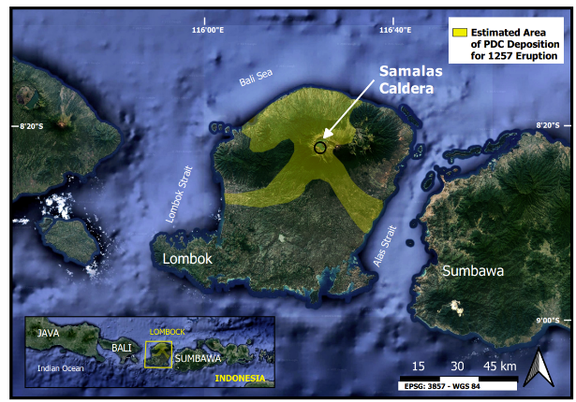Made preliminary Samalas locality figure in QGIS:

* DEM data from NASA EOSDIS
* PDC data from Lavigne et al 2013

Plot shows geographic location and gives eruption contect.

AP: Add F1 isopachs – important for showing prevailing wind direction at time of eruption.

**07/10/21**

Added F1 (Ultraplinian) Isopachs to Samalas Locality plot.

Installed Iris Package for python.

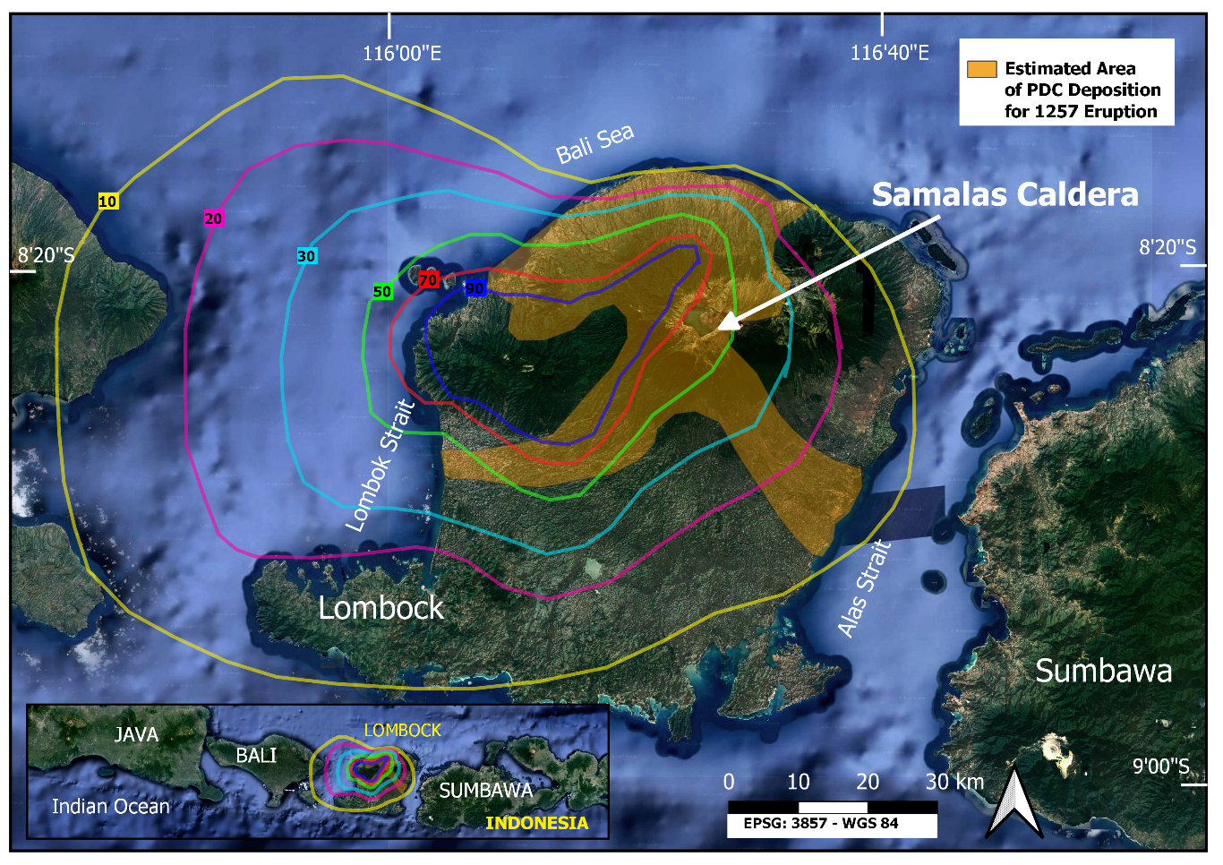**08/10/21**

Reading through Iris Documentation

AP: Resolve confusion over cube indexing (see tutorial scrips).

**10/10/21**

Worked through Iris tutorial and plotted example graphs.

**12/10/21**

VPN and ssh troubleshooted! Connection to chemistry desktop (brewer) now works. Next, some data?

**14/10/21**

Meeting with Lauren

How to Load Data to a Jupyter Notebook on my machine:

1. Connect to Chem VPN
2. Ssh to brewer
3. ‘module load anaconda’ ‘conda activate py27iris’ ‘jupyter notebook --no-browser --port=8879’
4. In local terminal: ‘ssh -N -f -L localhost:8888:localhost:8892 [username@brewer.ch.cam.ac.uk](mailto:username@brewer.ch.cam.ac.uk)’
5. Copy html address from brewer

= A Jupyter Notebook!

My data is stored at: /shared/netscratch/lrm49/Laura

* Use this path to load in data to a notebook.

Notes on Ensemble Runs

18 ensembles have been run. Key parameters have been varied: ENSO State (El Nino, La Nina, Neutral), QBO (Easterly or Westerly) and Timing (July or Jan).

AP: Troubleshoot Iris Installation. – Emailed IT Support, fixed by installing numpy 1.15.

Aims for the next week:

1. Fix Iris (DONE)
2. Load in data to a notebook (DONE)
3. Plot Aerosol Optical Depth time series for first ensemble – replicate Lauren’s example plot. (DONE)
4. Play around with SAT data.
   1. E.g SAT time series for single run (can later group by parameter)
   2. E.g global SAT heterogeneity maps
5. Characterise Ensemble runs by ENSO/QBO/Timing

* Need to write code to classify initial conditions.

AP: Read up on ENSO and QBO classifications.

**15/10/21**

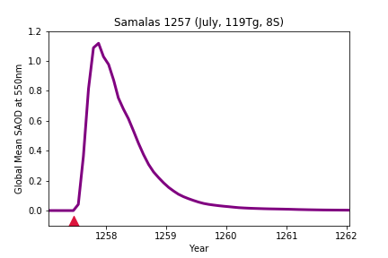Plotted global SAOD (Sulphur Aerosol Optical Depth) for different time intervals after the eruption + global mean SAOD timeseries:

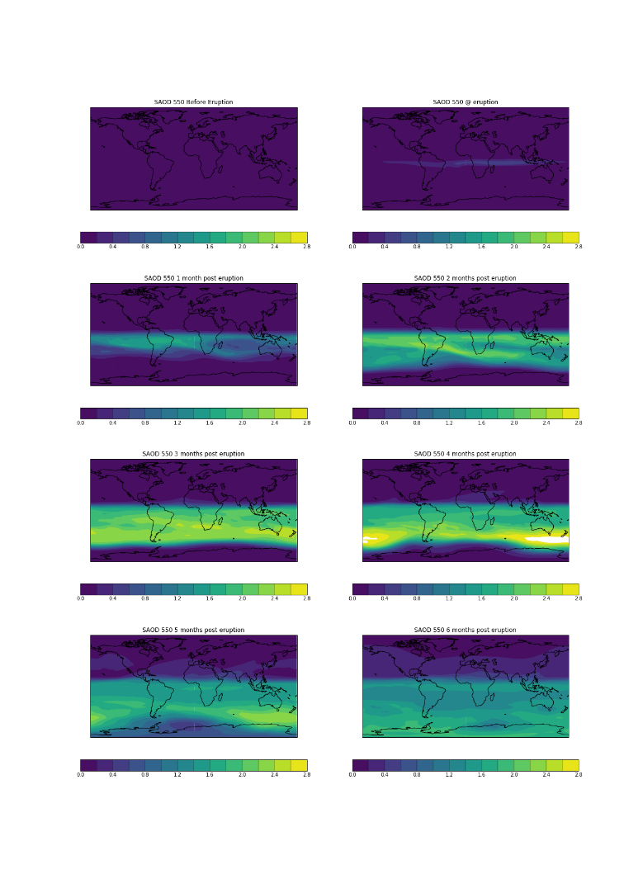

**Key Points:**

* Peaks in month 4.
* Returns to background levels within 18 months.
* Southern hemisphere loading > Northern Hemisphere – which is unexpected for a tropical eruption?

AP: Discuss choice of scale with Lauren – Log-scale resolution is too low, but non-log scale doesn’t pick up background.

AP: Plot regional SAT heterogeneity maps

AP: Also discuss with Lauren: Model resolution and uncertainties

**16/10/21**

Plotted global mean SAT time series:

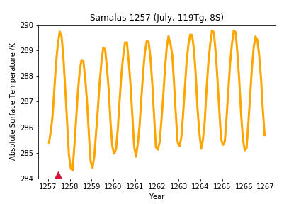

But temperature anomaly is obscured by seasonal cycles.

AP: plot SAT anomaly relative to control climatology.

**18/10/21**

Notes on QBO (Quasi-Biennial Oscillation):

* quasiperiodic oscillation of the equatorial zonal wind between easterlies and westerlies in the tropical stratosphere.
* Changes direction approx. ~ 14 months
* Easterly:
  + More chance of a weak Jet Stream
  + More chance of cold winters in Europe
* Westerly:
* More chance of a strong jet stream
* Milder Northern Europe winters, but heavier rainfall.

**19/10/21**

Loaded in all July ensemble dynamics data.

Plotted global mean SAT anomaly for each ensemble + ensemble means.

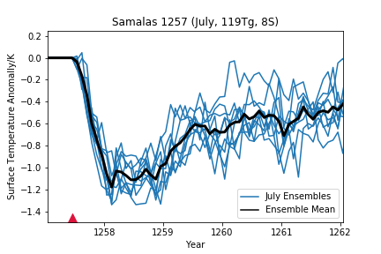

* Suggests cooling between -0.8 and -1.2K – which is broadly in good agreement with tree ring estimates.
* July ensemble runs are showing significant variability – possibly due to different initial conditions? But could also be internal variability.

Also plotted ensemble mean SAT anomaly on global map:

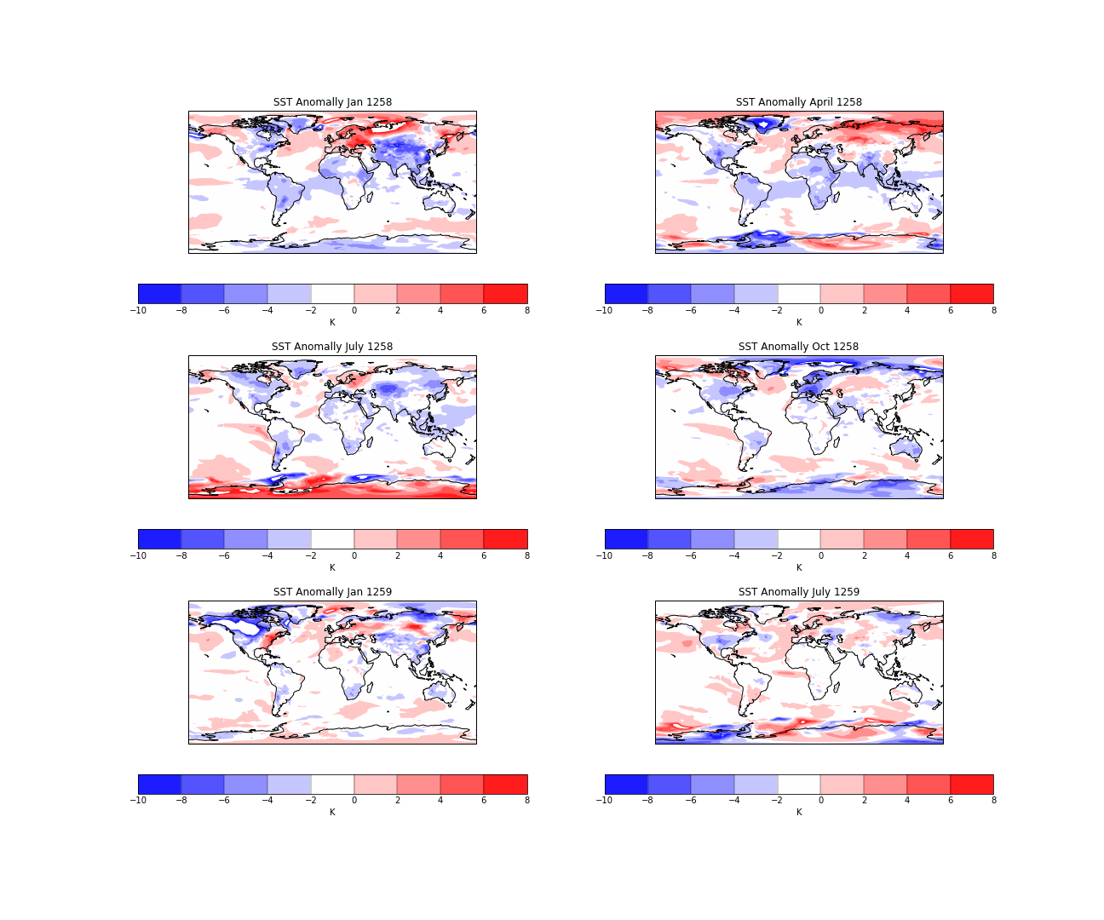

* Jan 1258 and Jan 1259 both show probably winter warming in Northern Europe (as expected)
* Spring/Autumn 1258 shows cooling – potentially in agreement with historical records (which is a positive sign!)
* Central Asia, North America seem to be areas of significant variability between models. N. America could be ENSO response related?
* Global Heterogeneity shows greater variability between runs than global mean T – so potentially a valuable way to constrain conditions.

To-Do:

1. Characterise ensembles by ENSO and QBO state.
   * QBO characterisation done using x_wind parameter at 30hPa between 15N-15S.
   * Need to consider time interval over which initial state is defined – single point, or running average?
2. Initial investigations of precipitation data
3. For SAT and precipitation compare Jan Vs July Vs proxy anomaly
4. Effect of ENSO/QBO initial conditions

**21/10/21**

Meeting with Lauren

To Do:

1. Plot ENSO timeseries and look up ENSO 3.4 definition
2. Consider paired (ensemble + identical control) or climatology (control average) for SAT anomalies
3. Jan SAT comparison
4. Look into precipitation data
5. Email Oli an update
6. VMSG Submission
7. Set up meeting with Anja

Additional notes from meeting:

* SAOD plots
  + Current scale likely obscures aerosol dispersion in the NH
  + But aerosol is especially concentrated in the SH – possibly a dynamical effect? I.e does QBO influence aerosol dispersion?
  + Lauren to help figure out log scale
* SAT plots
  + Paired anomalies can inflate the impact of internal variability
  + So alternative is to average control runs to create a climatology and subtract this from each ensemble (to better isolate effect of initial conditions)
* QBO characterisation
  + Need to consider timescale over which QBO is charactersied:
    - At start of run, 6 month average, time of eruption.
    - Can’t go beyond the point of the eruption as then QBO will be perturbed.

**25/10/21**

QBO Plots:

* Extracted x_wind from dynamics cubes
* Constrained to 15S-15N, all longitudes, pressure = 30hPa (Standard QBO definition)
* For each ensemble plotted x_wind timeseries for control and ensemble run – to see how they diverge.
* X_wind > 0 🡪 westerly, X_wind < 0 🡪 Easterly

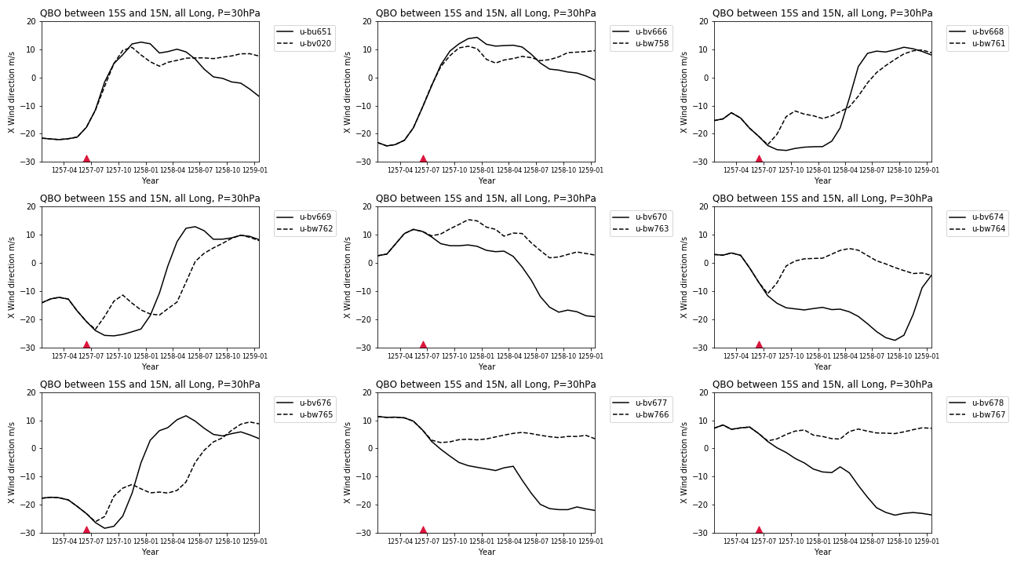

AP: Discuss with Lauren/Anja the most appropriate time period over which to define QBO.

Also see a pattern in how eruption perturbs QBO:

* When tending to westerly at point of eruption, perturbation is easterly.
* When tending to easterly at point of eruption, perturbation is westerly.

AP: Discuss this observation with Lauren/Anja – dynamical effect.

Made preliminary plots to investigate QBO influence on SAOD:

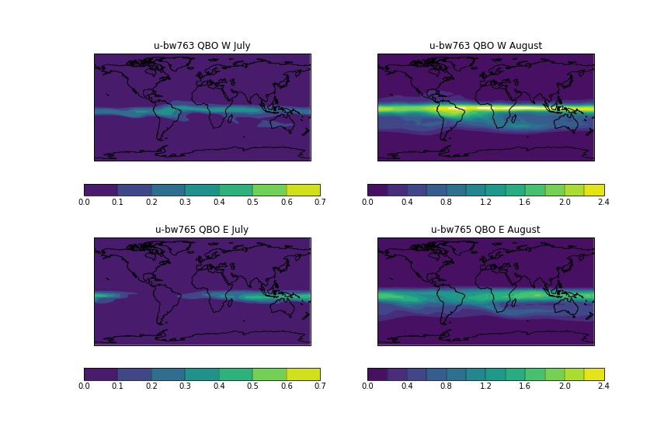

Westerly 🡪 faster spread to Africa/ SA. Whereas for Easterly QBO aersol is more concentrated over Indonesia.

Suggests initial QBO state (absolute + gradient) has significant control on aerosol dispersion.

ENSO plots:

Are finally working!

* Using ENSO 3.4 Definition: (5N-5S, 170W-120W). But not using 5-month running mean as not possible for Jan eruptions.
* Calculating ENSO SAT anomalies relative to 12 month climatology (averaged across control ensembles, then averaged by month across 10 years)
* Initial Characterisation suggests for July:
  + 3 El Ninos,
  + 3 Neutral
  + 3 La Ninas

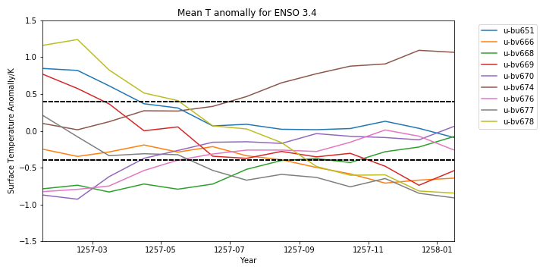

Additional thoughts:

* Can SAOD be considered to track aersol mass dispersion.
* QBO pertubations due to eruption are in agreement with prior research.
* QBO/ENSO characterisation has to be just prior to/at the point of the eruption to be consistent between July/Jan eruptions. But maybe also record gradient at that point?
* Need to discuss justification of constant eruption parameters with Lauren – column height, stratospheric SO2 load.

To-Do:

* Plot SAT anomaly (relative climatology) for July and Jan means + incorporate tree rings.
* Investigate QBO at different pressures
* Global SAT anomalies averaged across seasons + grouped by eruption timing/QBO/ENSO
* Statistical significance testing!
* Consider incorporation of historical and proxy records
* Global precipitation anomaly maps
* Finalise ensemble initial conditions.

**02/11/21 – 06/11/21 Illness meant unable to work.**

**07/11/21**

Plotted SAT anomaly for July Vs Jan Vs tree ring:

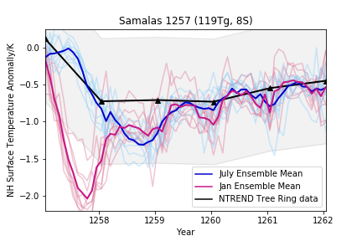

* Tree rings represent NH Summer Land SAT anomaly.
* So to make this most comparable to ensemble means need to apply constraints:
  + 40-70N
  + Summer average (Jun-July-Aug)
  + Masked out all ocean points

Also plotted global SAT heterogeneity plots:

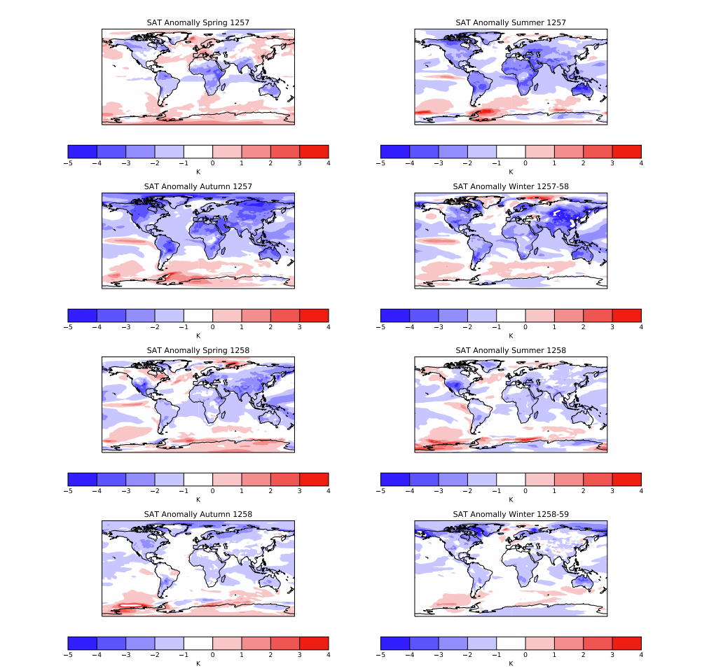

To-Do:

* Systematically collect and record proxy and historical data + consider how to display this effectively.
* Check characterization with Lauren
* Email Speleothem expert
* Get access to papers on historical impact.

**08/11/21**

Applied constraints to SAT tree ring plot:

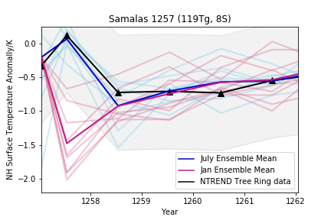

* July tracks very closely with tree rings but January is too early and cooling magnitude is too large 🡪 convincing evidence to discount winter 1257 eruption + favours summer 1257.
* Need to test this further by looking at spatially resolved temperature anomalies + precipitation anomalies.
* Also need to consider choice of tree ring chronology (see below) – different chronologies suggest slightly different magnitudes of cooling:

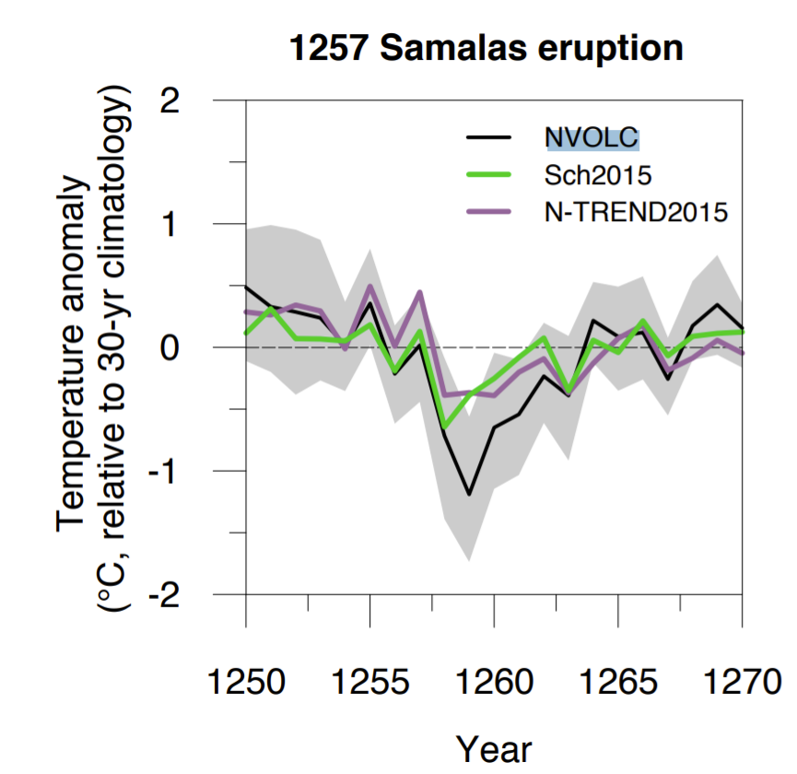

Precipitation data

* Wetting/drying pattern could suggest ITCZ shifts. Pattern also appears to be different between July/Jan

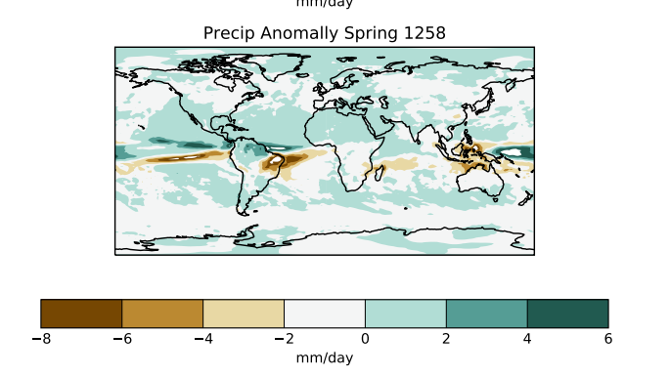

Shows northerly shift of ITCZ for July ensemble mean.

QBO Characterization

* Investigated effect of defining QBO at different pressures:

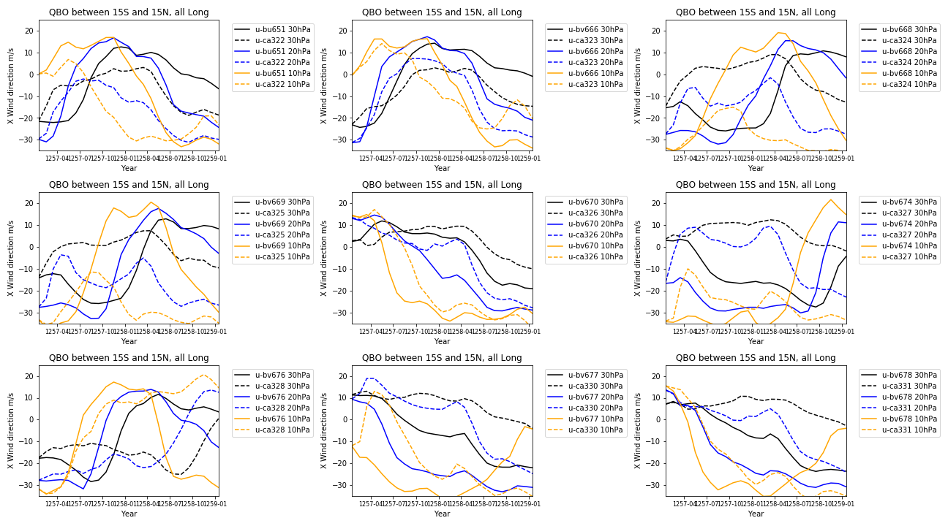

* 20 and 30hPa are generally consistent.
* After discussion with Lauren going to continue defining QBO at 30hPa.

ENSO Characterisation

* Corrected typo in previous code:

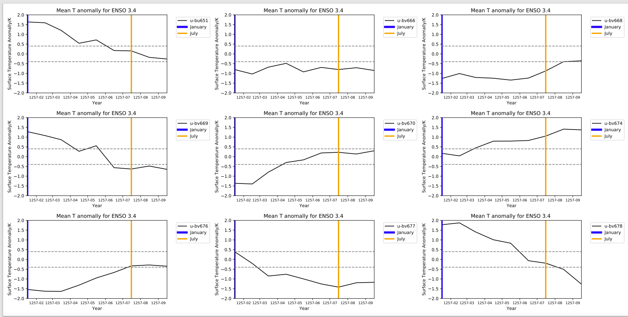

QBO Characterisation:

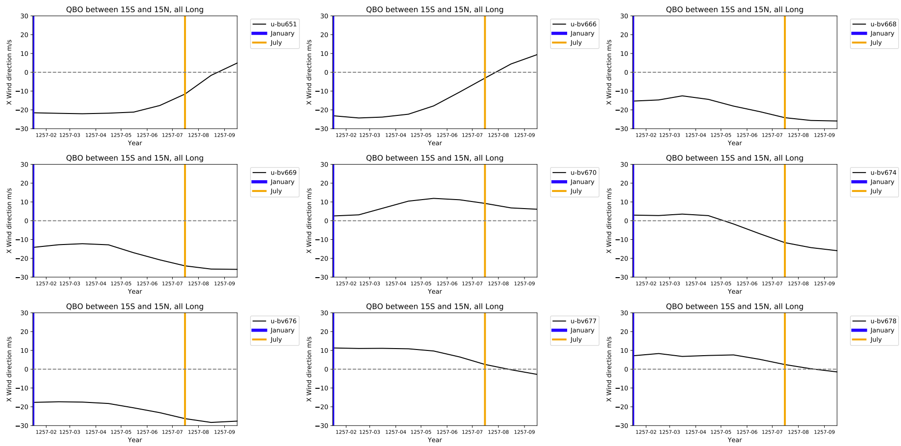For consistency ensemble initial conditions will be defined at the point of eruption:

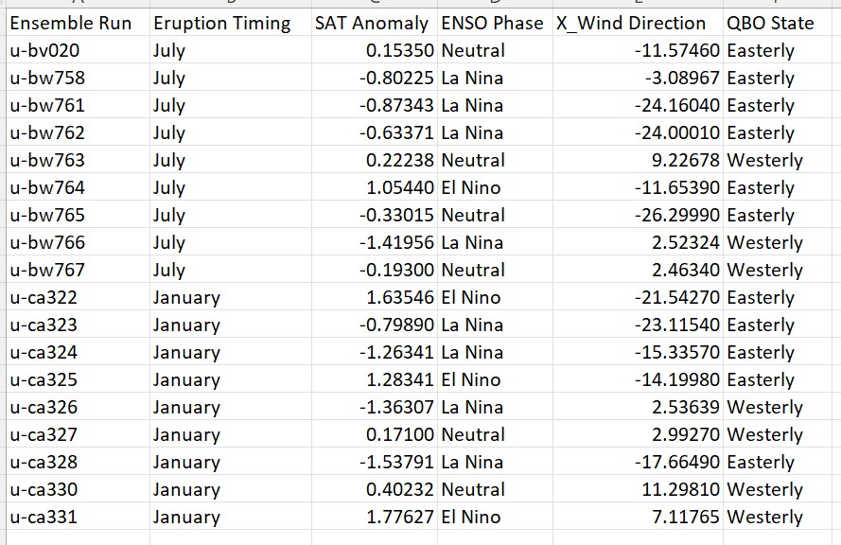

To-Do:

* SAOD timeseries plots
* For all ensembles:
  + Regional SAT plots
  + Regional Precip plots
  + SAOD
* Grouped by QBO and ENSO initial conditions:
  + Regional SAT plots
  + Regional Precip plots
  + SAOD
* Collect historical and proxy data.

**09/11/21**

Possible approaches to QBO analysis:

1. Average E/W across all Jan and July ensembles. Positive is that it is a more statistically robust method (larger sample size). Con is I currently can’t get the code to work to realign the dates….
2. Average E/W across runs for July/Jan separately. But this results in a really small sample size which is non-robust.

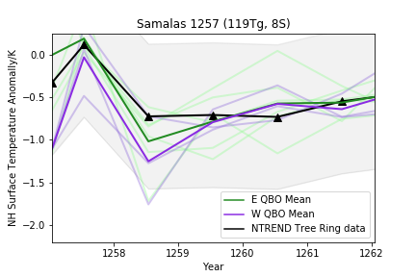 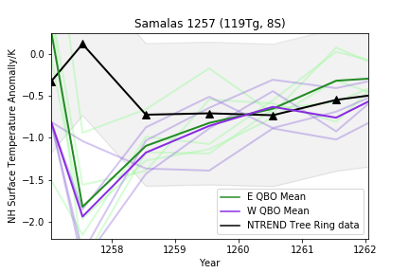

1. Compare QBO across like-for-like conditions (Timing/ENSO). But this could amplify the effect of internal variability (ie internal variability obscures any QBO signal)

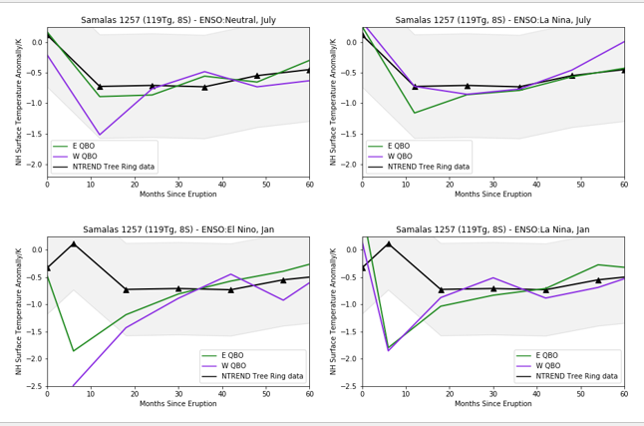

Ideally this sort of analysis would benefit from several hundred ensemble runs.

**10/11/21**

Started compiling proxy database. Mostly NH tree ring data so far…

Discrepancy between two studies WHICH USE THE SAME CHRONOLOGY! Because they use different length climatologies/running means. Highlights uncertainties associated with tree ring data.

AP: Find historical sources.

AP: Find Southern Hemisphere proxy data (if it exists)

AP: Investigate possibility of using stalagmite records. (Have emailed Alice Paine at Oxford)

Re Stalagmite records difficulty is finding a record with sufficiently high resolution + suitable location to track ITCZ changes.

Plotted SAT by QBO starting condition:

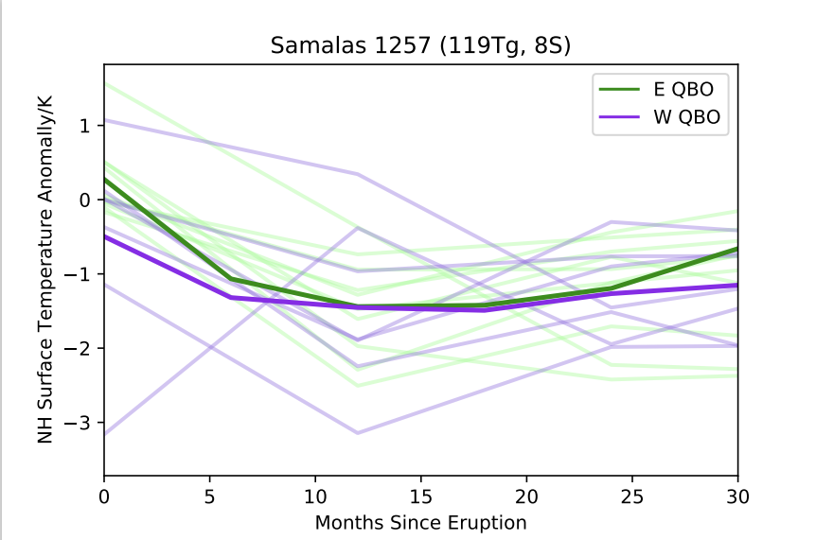

Doesn’t show an especially significant signal?

Plotted SAT by ENSO starting condition:

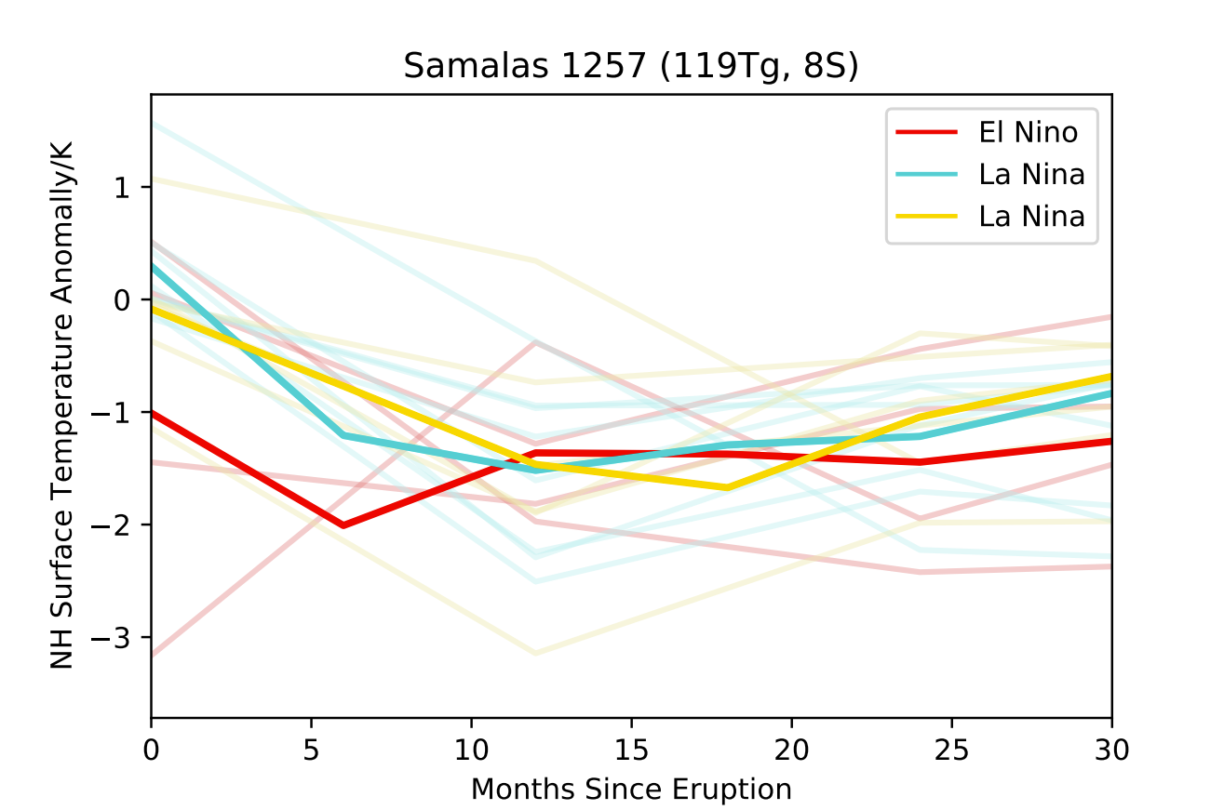

* Either QBO signal << other signals (Timing/ENSO) and internal variability
* Or QBO condition does have significant influence on aerosol distribution BUT dynamical effects mean this doesn’t translate to SAT anomaly difference

AP: Test this by investigating effect of QBO starting condition on SAOD

Plotting SAOD ratio (NH-SH/NH+SH) – proportion of aerosol optical depth in NH:

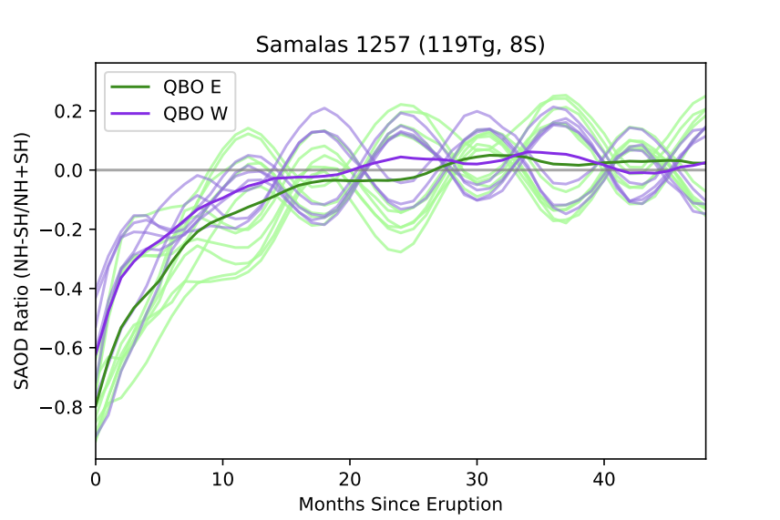

+ similar plots for Eruption timing/ENSO:

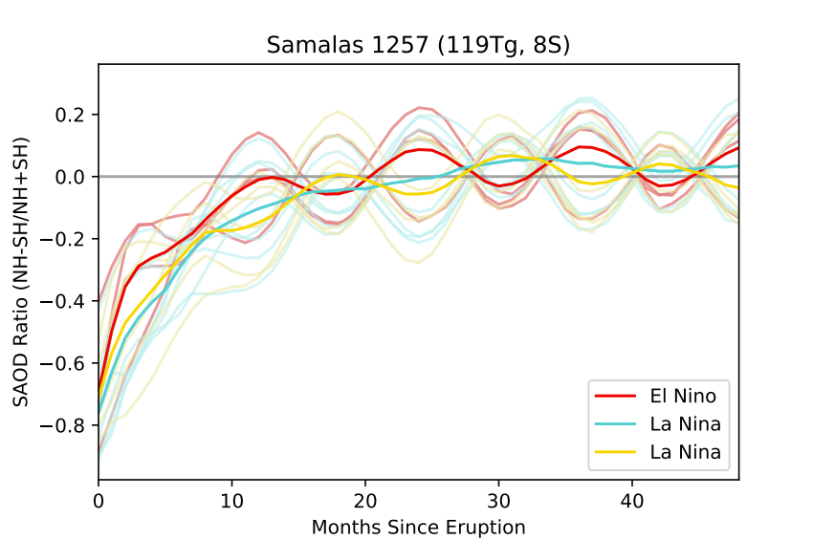

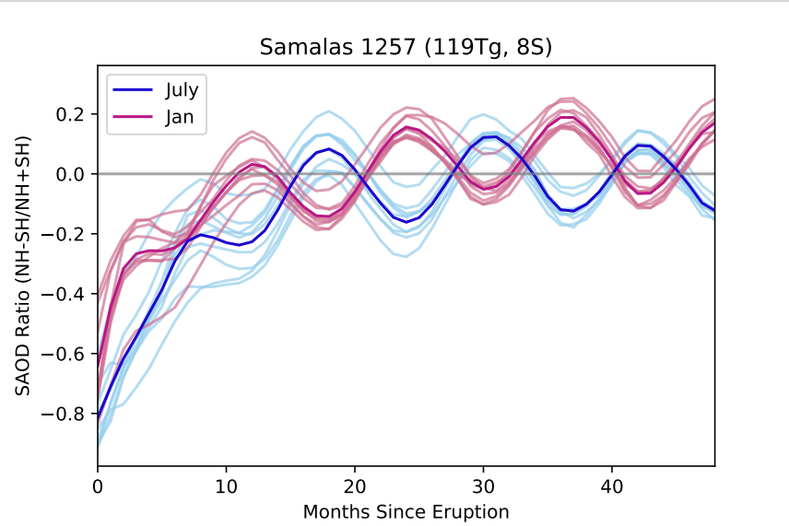

Both show convincing differences for timing + QBO state.

AP: Need to think about this more.

To-Do:

* Create proxy database + visualisation
* Repeat SAOD ratio plot by ENSO state
* Statistical testing for precip/temperature plots
* Investigate ENSO perturbations
* Make matrix plot by initial conditions.

**11/11/21 – 21/11/21 Kidney Infection. Confined to bed/A&E.**

**22/11/21**

Created initial conditions matrix:

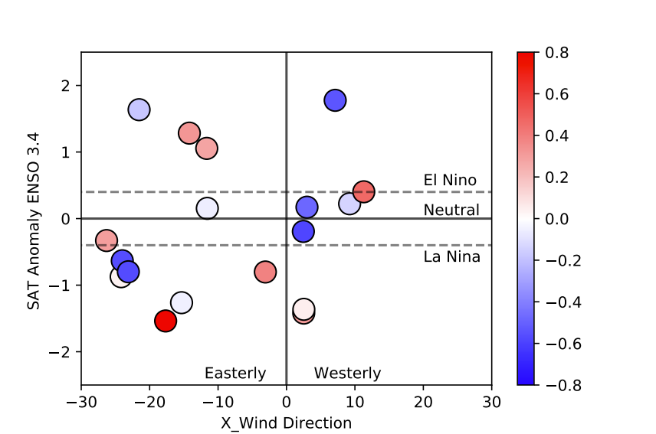

Doesn’t show significant clustering in terms of maximum SAT anomaly by QBO or ENSO state. Also issues here with code re two colour bars for Jan/July.

AP: Investigate different versions of this plot (constraints, SAT definition).

Proxy data

* Don’t want to just repeat previous work (ie Guillet) so need to focus on novel angle (I.e spatially resolved SAT)
* But still useful to incorporate their work.

NTREND

Spatially resolved tree ring chronology for NH. Plotted using a 3 year, 5 year, and 10 year to test effect of climatology length – all produced very similar plots:

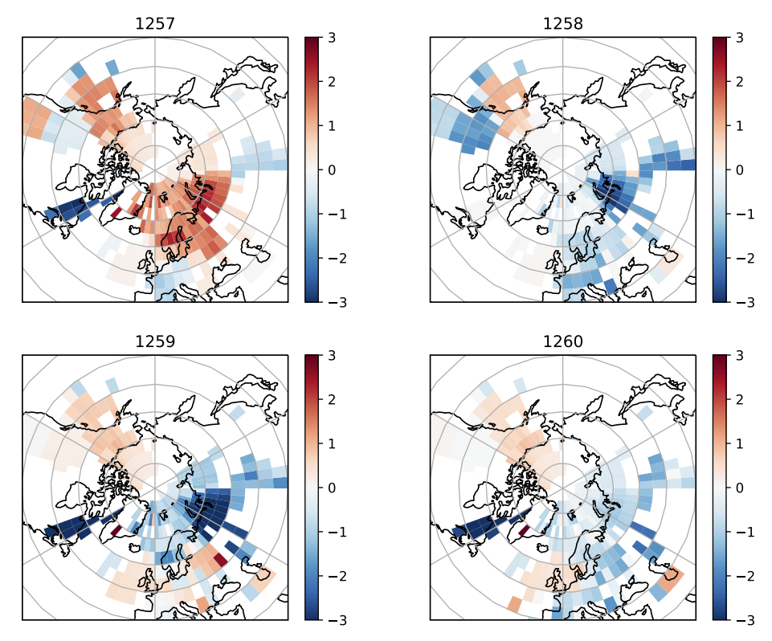

Also converted SAT plots to polar maps for easier comparison:

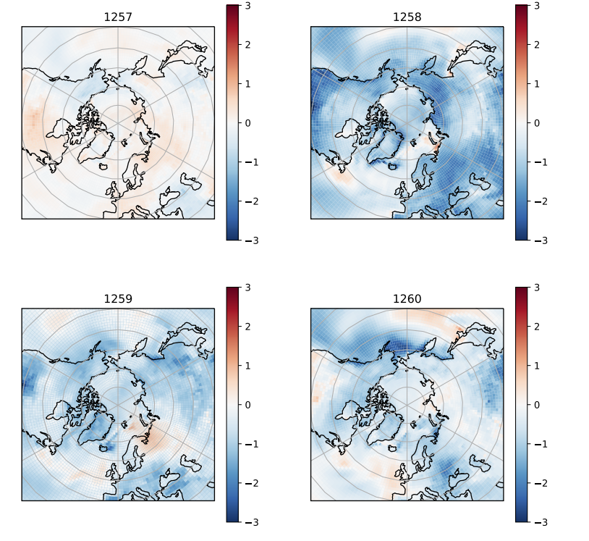

Regional heterogeneities may provide even better constraints (particularly for QBO/ENSO state where global mean is unconvincing.

AP: Investigate appropriate statistical testing – t-test? Causing significant issues….

**23/11/21**

Meeting with Alice Paine (PhD student at Oxford looking at volcanic signals in stalagmite records).

* ITCZ seasonality means Samalas caldera in in the NH in January, and SH in July.
* ITCZ shifts will also result in their own temperature anomaly
* ITCZ shifts away from the hemisphere that cools.

Also emailed James Baldini (Durham) re possible stalagmite records. Would be ideal to have additional equatorial/SH data points.

AP: Background reading on volcanic-induced ITCZ shifts

AP: Investigate ENSO perturbations (timing and starting state dependency)

To-Do:

* Start writing intro and methods
* Tree ring plots
* Proxy visualisation
* Stalagmite records/plots
* ITCZ analysis
* Continue Matrix Plots

**24/11/12**

Meeting with Anja:

1. Matrix Plots
   1. Plot absolute NH Summer Land SAT anomaly with different symbols for Jan/July eruption.
   2. Plot SAT – Tree ring to see which runs are better matched.
2. Global Mean SAT plot – add additional tree ring chronologies.
3. Review appropriate statistical tests (go to Stats Lab)
4. Visualise global proxy records.
5. Apply mask to SAT polar plots to make them more easily comparable to NTREND polar plot.
6. Investigate ITCZ response.
7. Plot stalagmite timeseries

Stalagmites – have found YOK-I oxygen and carbon isotope data. Belize is a good equatorial location for tracking ITCZ shifts + has sub-annual resolution.

ENSO perturbations due to eruption by starting condition:

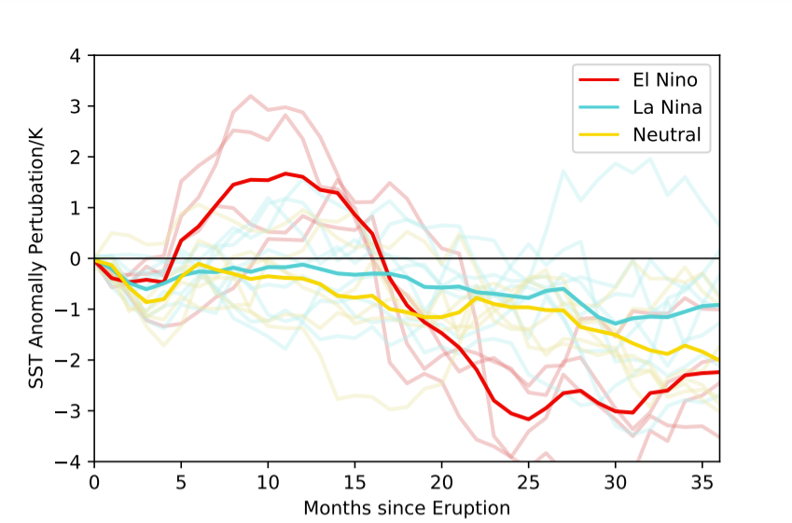

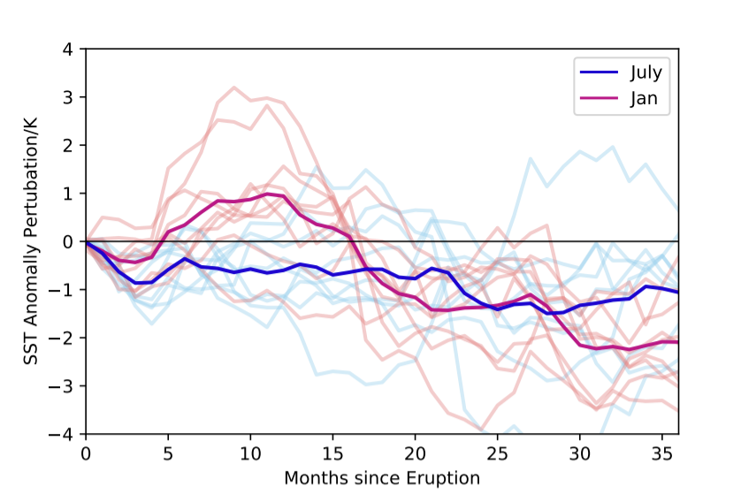

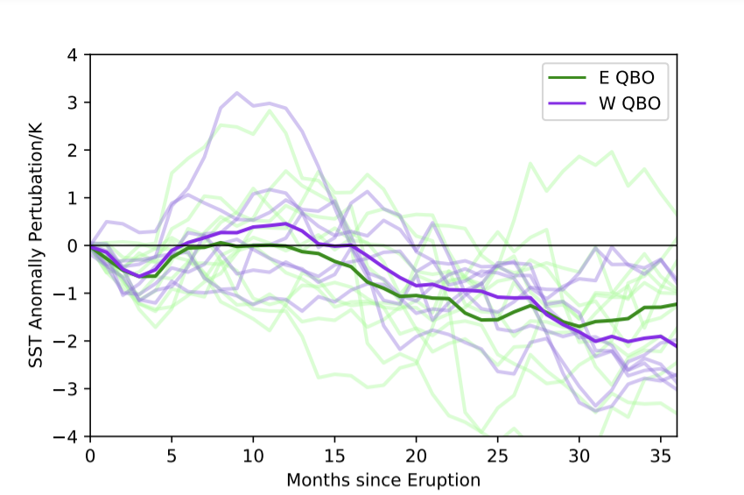

Suggests initial ENSO starting condition + timing of eruption are potentially significant control on ENSO response to eruption.

**26/11/21**

Updated matrix plots. Tried many different versions/combinations of constraints. Current best one:

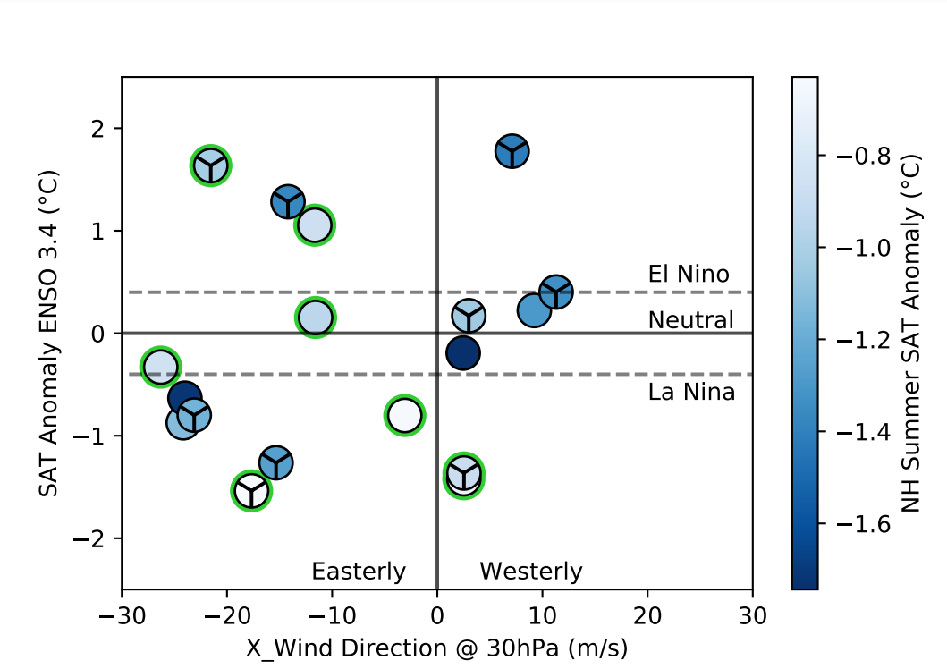

Shows NH 1258 Summer Land SAT. Trig symbol = jan ensemble. Green halo = within two SD of tree ring.

Initially suggests some preference for Easterly – but only 6/11 so probably not statistically significant.

**27/11/21**

Added additional tree ring chronologies to Global Mean SAT plot:

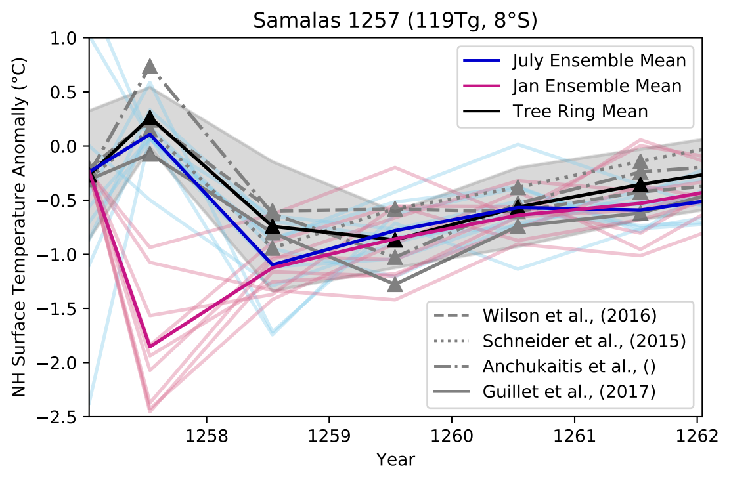

Also completed global proxy map:

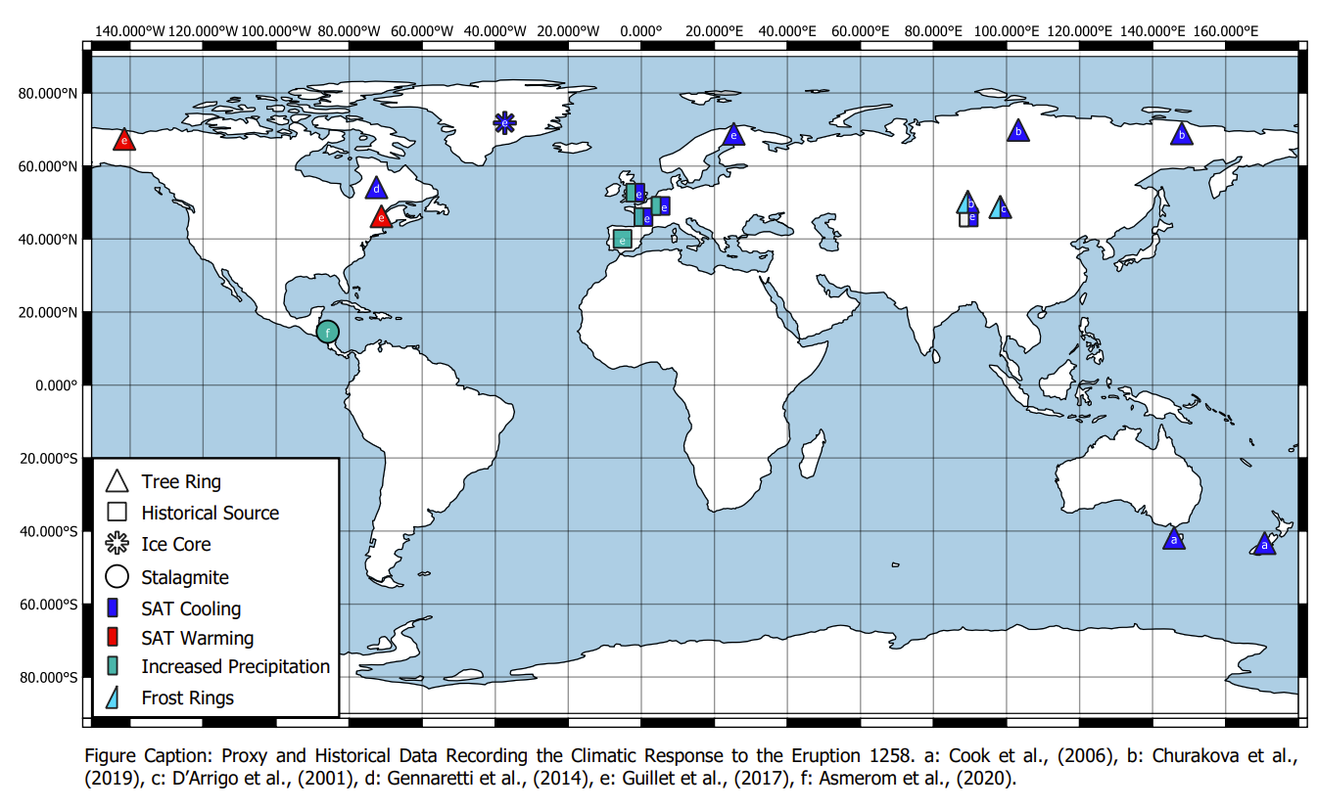

Still limited by lack of SH data – but can comment on this in report.

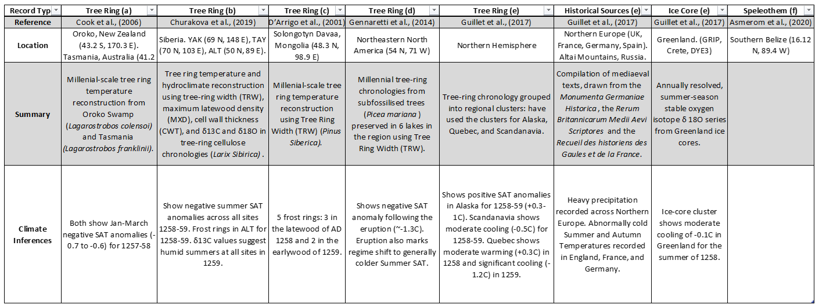

Accompanying table.

**28/11/21**

Plotted stalagmite data:

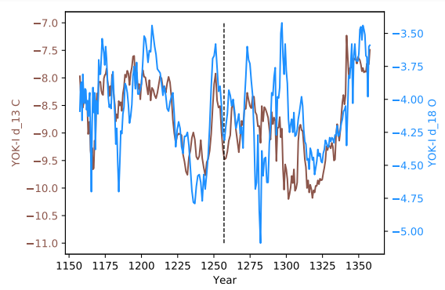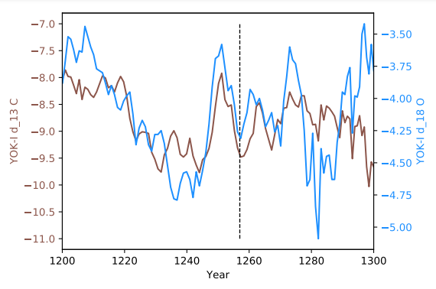

Plotted over different timescales. Showing oxygen and carbon isotopes.

To-Do:

* Contact dept stalagmite expert (possibly Stacy Carolin)
* Reread YOK papers to understand their interpretation
* Need to consider timescales/accuracy of records and how this limits their application as model constraints.

**04/12/21**

Stats Clinic (Run by Dept Maths)

* T-test and z-scores are not considered statistically robust given many dependencies in the model
* So instead advised to use an ANOVA approach
* Method tests for significance of data at a given point in time (ie 1258) relative to background state.

**06/12/21**

Meeting with Anja

* Need to regrid Polar SAT plots (talk to Lauren about this)
* Tree ring discrepancies are important to discuss in report.
* Global proxy map – make continents grey, ocean white.
* Don’t over interpret stalagmites – talk to expert!
* Plot precip timeseries
* Run ANOVA analysis on more powerful machine (send script to Lauren)
* Tidy up tree ring plot
* Prepare VMSG poster + flash talk.

**08/12/21 – 10/12/21**

(Eventually) Regridded polar SAT plots:

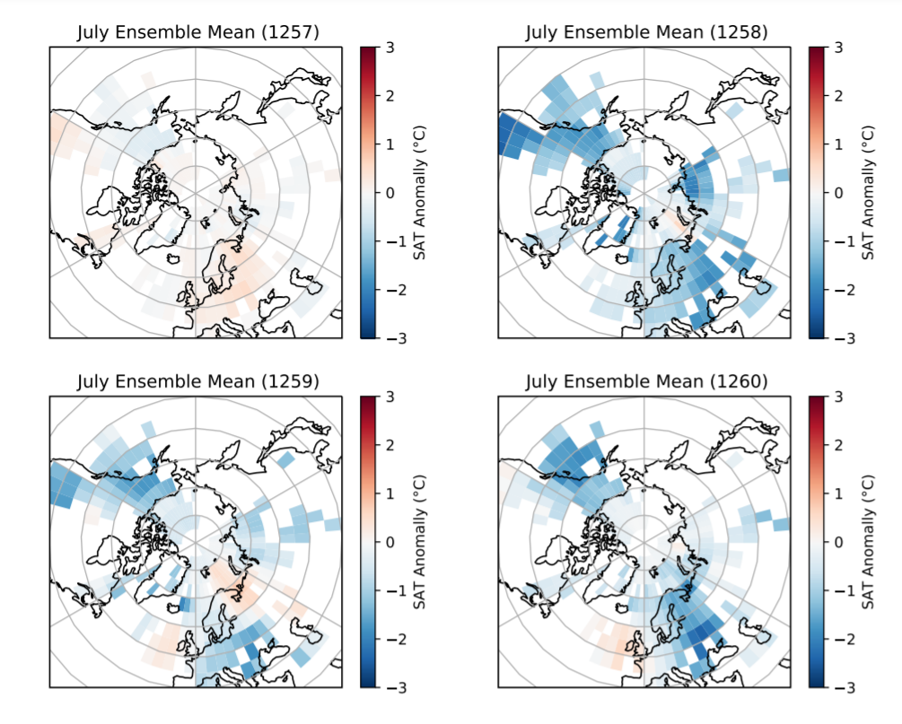

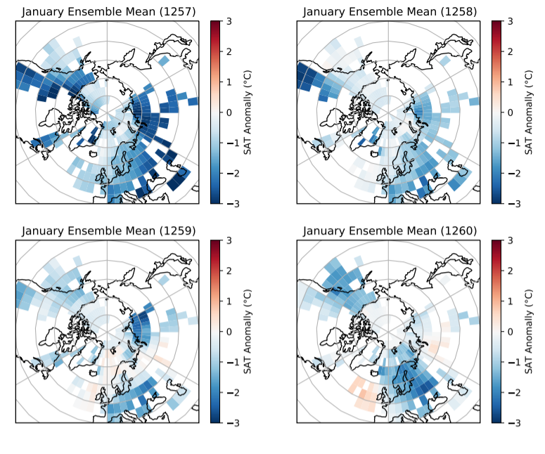

Provides additional constraints on eruption timing – July ensemble agrees pretty well, Jan ensemble far too cold in 1257.

Also updated matrix plot as was previously too complicated/ not showing significant result:

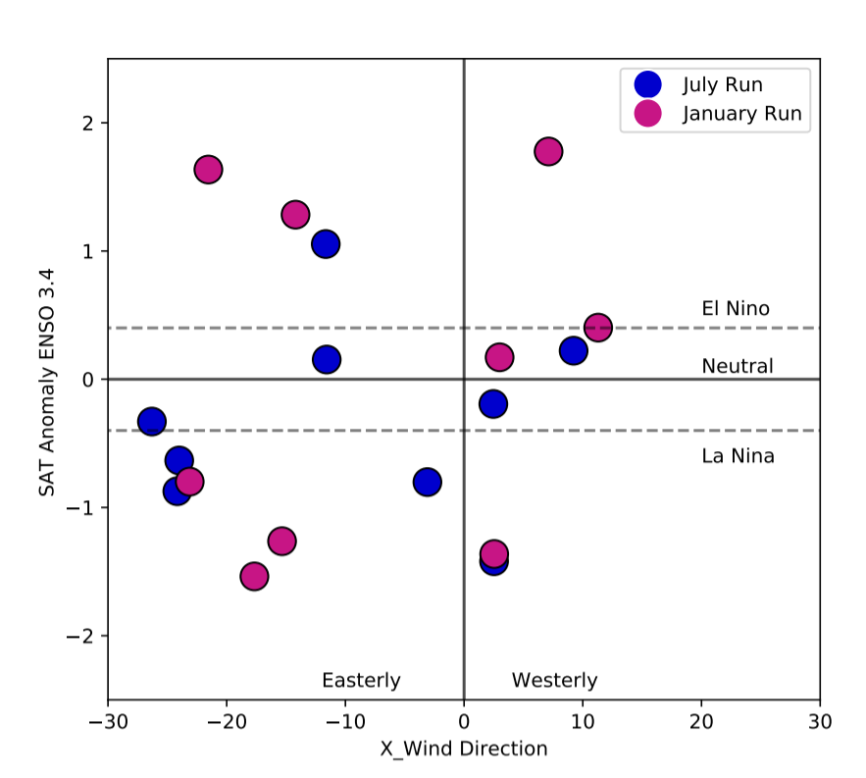

**11/12/21-18/12/21**

Making VMSG poster and flash talk. Focussing just on eruption timing as that is the most complete/significant section of work.

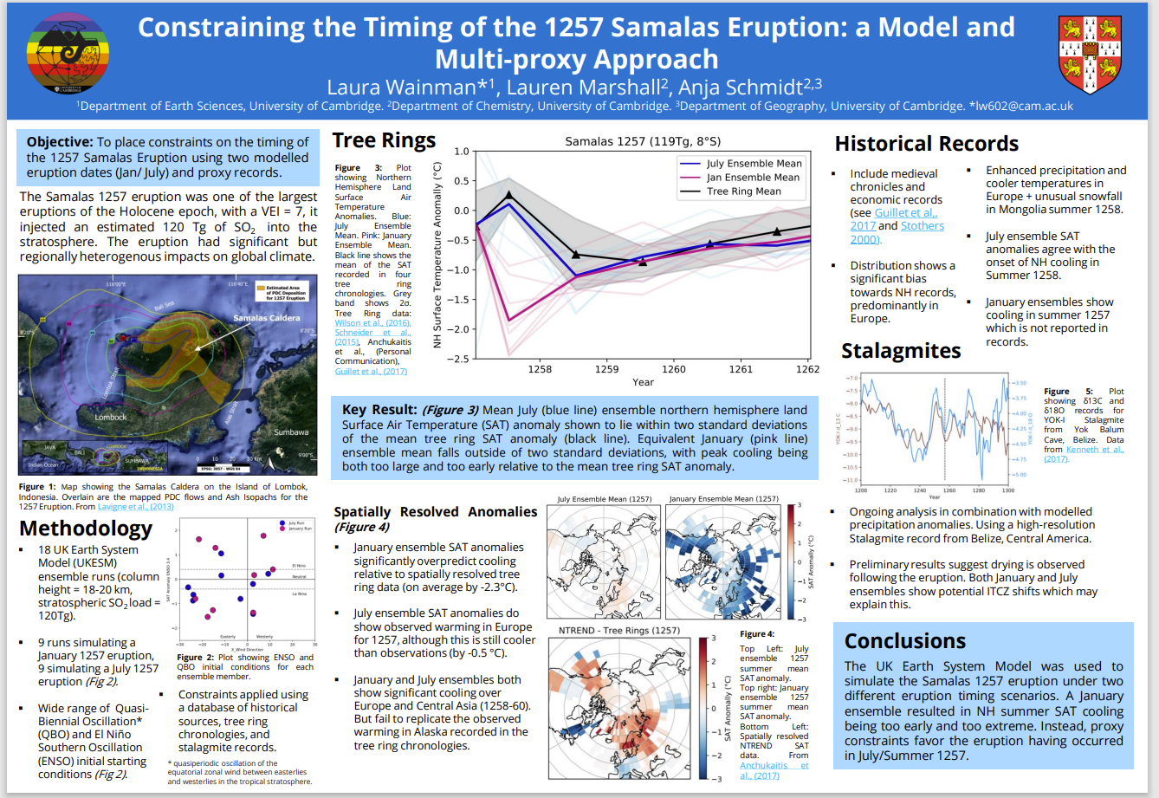

VMSG Poster.

**02/01/21**

Submitted VMSG poster and flash talk. (Phew)

AP: Need to discuss details of the model with Lauren in greater depth.

To-Do:

* Start write up.
  + Discuss methods (UKESM) in more detail with Lauren.
* More comprehensive understanding of stalagmite result
* Redesign proxy plot
* Resolve statistical significance testing.

**10/01/22 – 12/01/22**

Attended VMSG!

Great experience overall – really inspiring to see PhD and ECR work.

Some learnings/thoughts:

* Plume grain size distribution plays a really important role in plume/aerosol dispersion – need to understand how this occurs in the model/ what the limitations are.
* Include captions and pronouns for talks to be more inclusive.
* QR codes on posters are cool.
* Good talks seem to generate the most questions!

Was given an Honourable Mention (top 3) for my poster! Really exciting 😊

**14/01/22**

Writing introduction – aim is to introduce the importance of eruption source parameters/the Samalas eruption/ where the uncertainties are/ project objectives and approach. So much reading to do!

Questions to discuss with Lauren re methodology:

* How are aerosol microphysics included in the model? Ie how are key particle characteristics set/ evolve over time?
* Does it include the full life cycle of Sulphur particels/ aersol?
* What is the specific name of the model? Have multiple models been combined? Ie a specific configuration or GLOMAP-mode aerosol microphysics scheme?
* Horizontal resolution?
* How many vertical levels?
* How to describe ocean-atmosphere coupling?
* What background climatic state is used? Pre-industrial?
* What other eruptions has the model been tested on? Evidence it performed well?
* Where are the main limitations?
* Constant parameters: SO2 load – 119Tg (where is this from?), injection height -18-20km (does this = plume height of 43km/ what’s the injection depth)? What is eruption duration in the simulation?
* Changing parameters: Timing, QBO start, ENSO start.

Other things to discuss:

* Precip anomalies and stalagmite application
* Statistical testing

NEW IDEA FOR FINAL PLOT!

|  |  |  |  |  |  |  |  |  |
| --- | --- | --- | --- | --- | --- | --- | --- | --- |
|  | Key | Proxy | Markers |  |  |  |  |  |
| Ensemble Members |  |  |  |  |  |  |  |  |
|  |  |  |  |  |  |  |  |  |
|  |  |  |  |  |  |  |  |  |
|  |  |  |  |  |  |  |  |  |
|  |  |  |  |  |  |  |  |  |
|  |  |  |  |  |  |  |  |  |

**16/01/22**

Continued to write intro.

Stalagmite investigations continue…

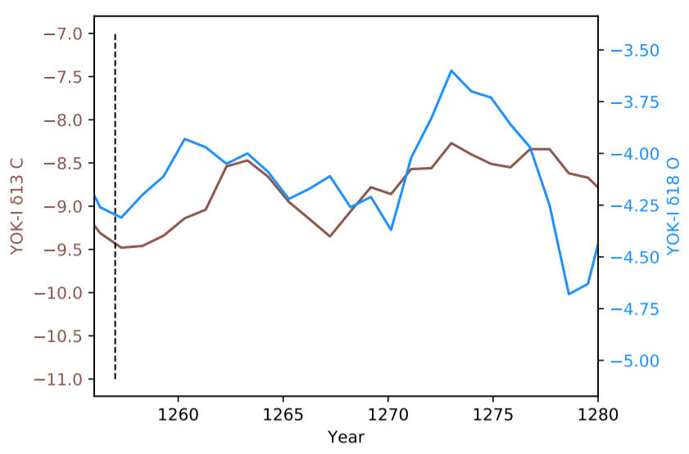

Stalagmite isotope evolution following the eruption. Preliminary thoughts are this shows a drying signal with approx. 5 month resolution.

AP: Need to review papers from cave to understand what this signal is showing/ where the complexities are.

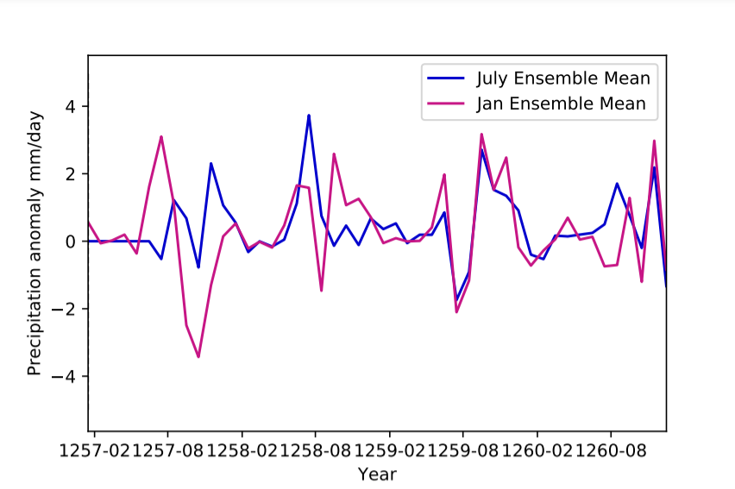

Timeseries from Cave grid box – but note probably too large to be representative. Doesn’t show signal particularly comparable with record. Jan reversal and is interesting.

AP: Play about with averages/timing/means for this plot.

AP: Similar plot for all longitudes/latitude band.

**17/01/22**

Meeting with Lauren

* Agreed focus now is on writing up – this will reveal gaps in analysis and knowledge. Aiming to have first draft by early February.
* Stalagmites – not clear relationship between record and model time series. But still include a discussion of where the limitations are with this – is the gird box representative of that cave?
* Run cave grid box time series as individual ensemble runs – mean might not be representative.
* Run all longitude, latitude band time series? Or maybe stick with global plots?
* ITZC shifts could have important links to aerosol distribution and ENSO response – probably not enough work here to “prove anything” but can still incorporate into discussion.
* Year is “meaningless” – ie Jan could be 1257 or 1258. So can also rule of 1258 Jan eruption timing. Play about with SAT plot for this.

NH eruption – southwards shift of ITCZ – weakening of trade winds – El Nino

**Up to 12/02**

Write up – completed first draft.

To-Do list:

Statistical testing of precip and temp anomalies

Add github link to appendix

**16/02/22**

Figured out statistical testing using scipy ANOVA analysis – grid point. Constrain anomalies to 95% significance level

For July Vs Jan precip and SAT plots – use to analyse effect of eruption season.

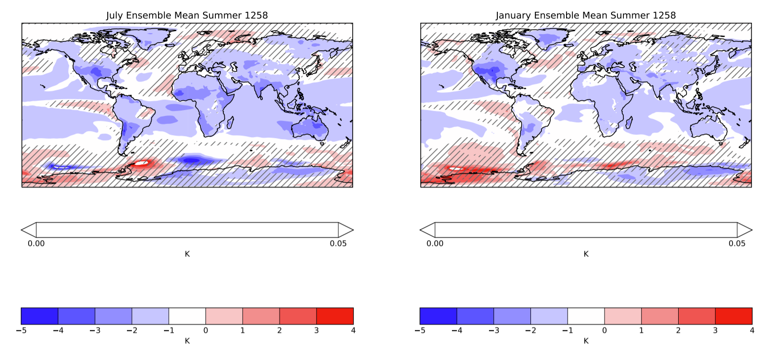

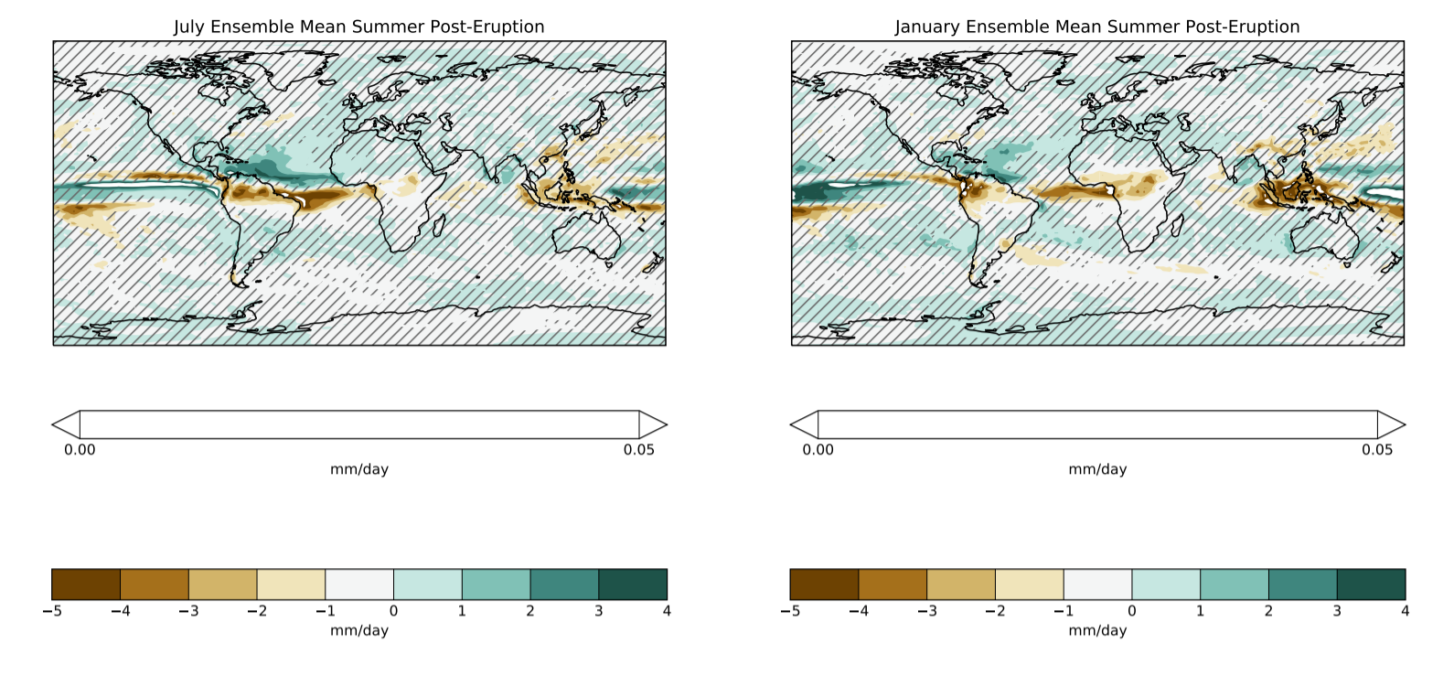

Considered statisitical testing for individual ensemble plots – but anova analysis doesn’t work for just one ensemble.

Decided best to remove individual precip plots. Replace with Jan Vs July and El Nino Vs the rest to consider eruption parameter effects. And no precip proxy comparison available anyway…

AP: Make El Nino Vs the rest precip hashed plots.

AP: Consider if statistical testing is feasible for individual SAT plots

AP: Adapt write up to reflect new plots

AP: Make sure everything is for 1258

